Spiritual Mindedness Week 3
True and False Signs of Spiritual-Mindedness

2 Corinthians 13:5 (NKJV) – Memory Verse
"Examine yourselves as to whether you are in the faith. Test yourselves. Do you not know yourselves, that Jesus Christ is in you?—unless indeed you are disqualified."

Summary of Chapters 3 & 4: True and False Signs of Spiritual-Mindedness
John Owen emphasizes that while spiritual thoughts can indicate the presence of the Spirit, they are not conclusive proof of being spiritually minded. People may delight in their religious experiences rather than in God Himself. True spiritual-mindedness is revealed in a heart where spiritual thoughts reside naturally, rather than needing to be deliberately forced.
Owen warns against relying on external influences like preaching, prayer, or fellowship as the primary source of spiritual thoughts. While these can stir godly thoughts, true spiritual-mindedness arises from an inward work of grace that transforms the heart’s desires and inclinations. Spiritual thoughts must replace carnal thoughts rather than coexist with them. True believers will undergo continual self-examination to discern their spiritual state.

Key Themes
- Self-Examination.
- Natural vs. Induced Spiritual Thoughts
- The Danger of Self-Deception
- Reliance on Religious Activity leads to Hypocrisy
- True Spiritual-Mindedness Brings Transformation

Outline of Lesson 3
- Christians Have the Spirit Active in Their Thought Life
  - Responsibility to actively pursue spiritual thoughts
- Spiritual Thoughts as Evidence, but Not Conclusive Proof
  - Delighting in God vs. delighting in religious experience
  - The necessity of true transformation
- What Produces Spiritual Thoughts?
  - External influences (preaching, prayer, conviction, fellowship)
  - True spiritual-mindedness flows from inward grace
- How Hypocrites Deceive Themselves
  - Treating religious activity as evidence of faith (Matthew 7:21-23)
  - Working for salvation vs. working because of salvation
- False Signs of Not Being Spiritually Minded
  - Struggles in prayer, dryness, awareness of sin
  - True spiritual-mindedness relies on Christ’s performance
- The Role of Prayer in Spiritual-Mindedness
  - Examining motives in prayer
  - Carnal vs. spiritually-minded prayers
- Evidence of True Spiritual-Mindedness
  - Spiritual thoughts bring peace and satisfaction
  - Leads to obedience, sanctification, and humility
  - A truly spiritual person naturally inclines toward Christ
Spiritually Minded – Growing in Grace

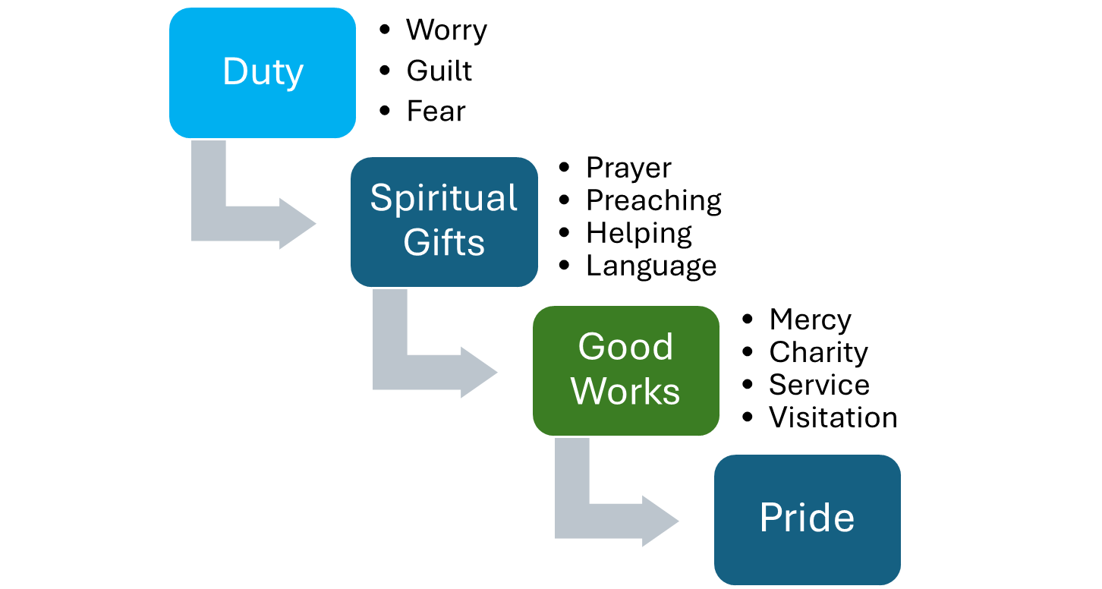
Carnally Minded – Satisfying Self

Quote from John Owen
"The soul finds a sweet, spiritual satisfaction in them. A truly spiritually-minded person delights in thoughts of God, not just duty."

Discussion Questions
- How might self-examination differ between a Spiritually Minded person and a Carnally Minded person?
  - Subject of assessment: God’s work vs. my work?
  - How might the goals differ?
  - How might the emotions differ?
- Are spiritual thoughts that arise from external influences useful or useless?
- Is it better to self-examine when struggling or when not struggling?

Application & Reflection
- Self-Examination: Make a habit of reflecting on God’s work in your life. Focus on evidence of His work in you, not just your work being satisfactory.
- Meditate on 2 Corinthians 13:5: Ask God to help you discern your heart’s true state.
- Guard Your Prayer Life: Ensure your prayers are not focused on carnal thoughts.
- Pray for and Hope for Growth in Grace: Seek increased faith, hope, joy, and love.

Reading Assignment
📖 Chapter 2: 3-4: True and False Signs of Spiritual-Mindedness (Abridged by R. J. K. Law)

